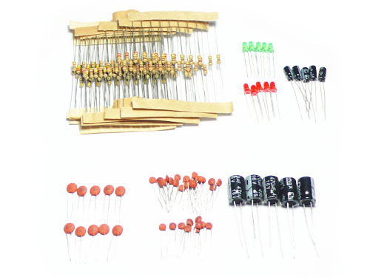
Resistor
- 2.2Ω*10
- 10Ω* 10
- 47Ω*10
- 100Ω*10
- 680Ω*10
- 1kΩ*10
- 10kΩ*10
- 22kΩ*10
- 68kΩ*10
- 100kΩ*10
- 330kΩ*10
- 1MΩ*10
Ceramic Capacitor
- 100pF*10
- 10nF*10
- 100nF*10
- 2.2nF*10
Electrolytic capacitor
- 10uF* 5
- 470uF* 5
LED
- 3mm Red*5
- 3mm Green*5

